Conner Tenn

Course: ICS4U1-01

Date Started: Jan 16

Date Delivered: Jan 23

Last Updated: Jan 22

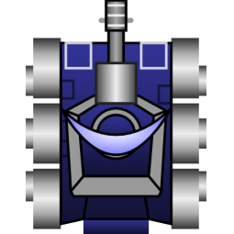

Robocode

Design Proposal:

The design of my robot can be broken down into three main parts; The scanner algorithm, the targeting algorithm, and the driving algorithm.

The scanning algorithm consists of 2 main states. These states are scanning for targets and tracking a target. When the game begins, the robot will begin by scanning in a complete circle and determine what target is the highest priority. Once a complete scan has been made, the robot will shift into tracking mode where it will lock onto and track the highest priority target. If no target is found. It will scan again. While tracking, the last know position and behavior of the target will be extrapolated to provide better tracking.

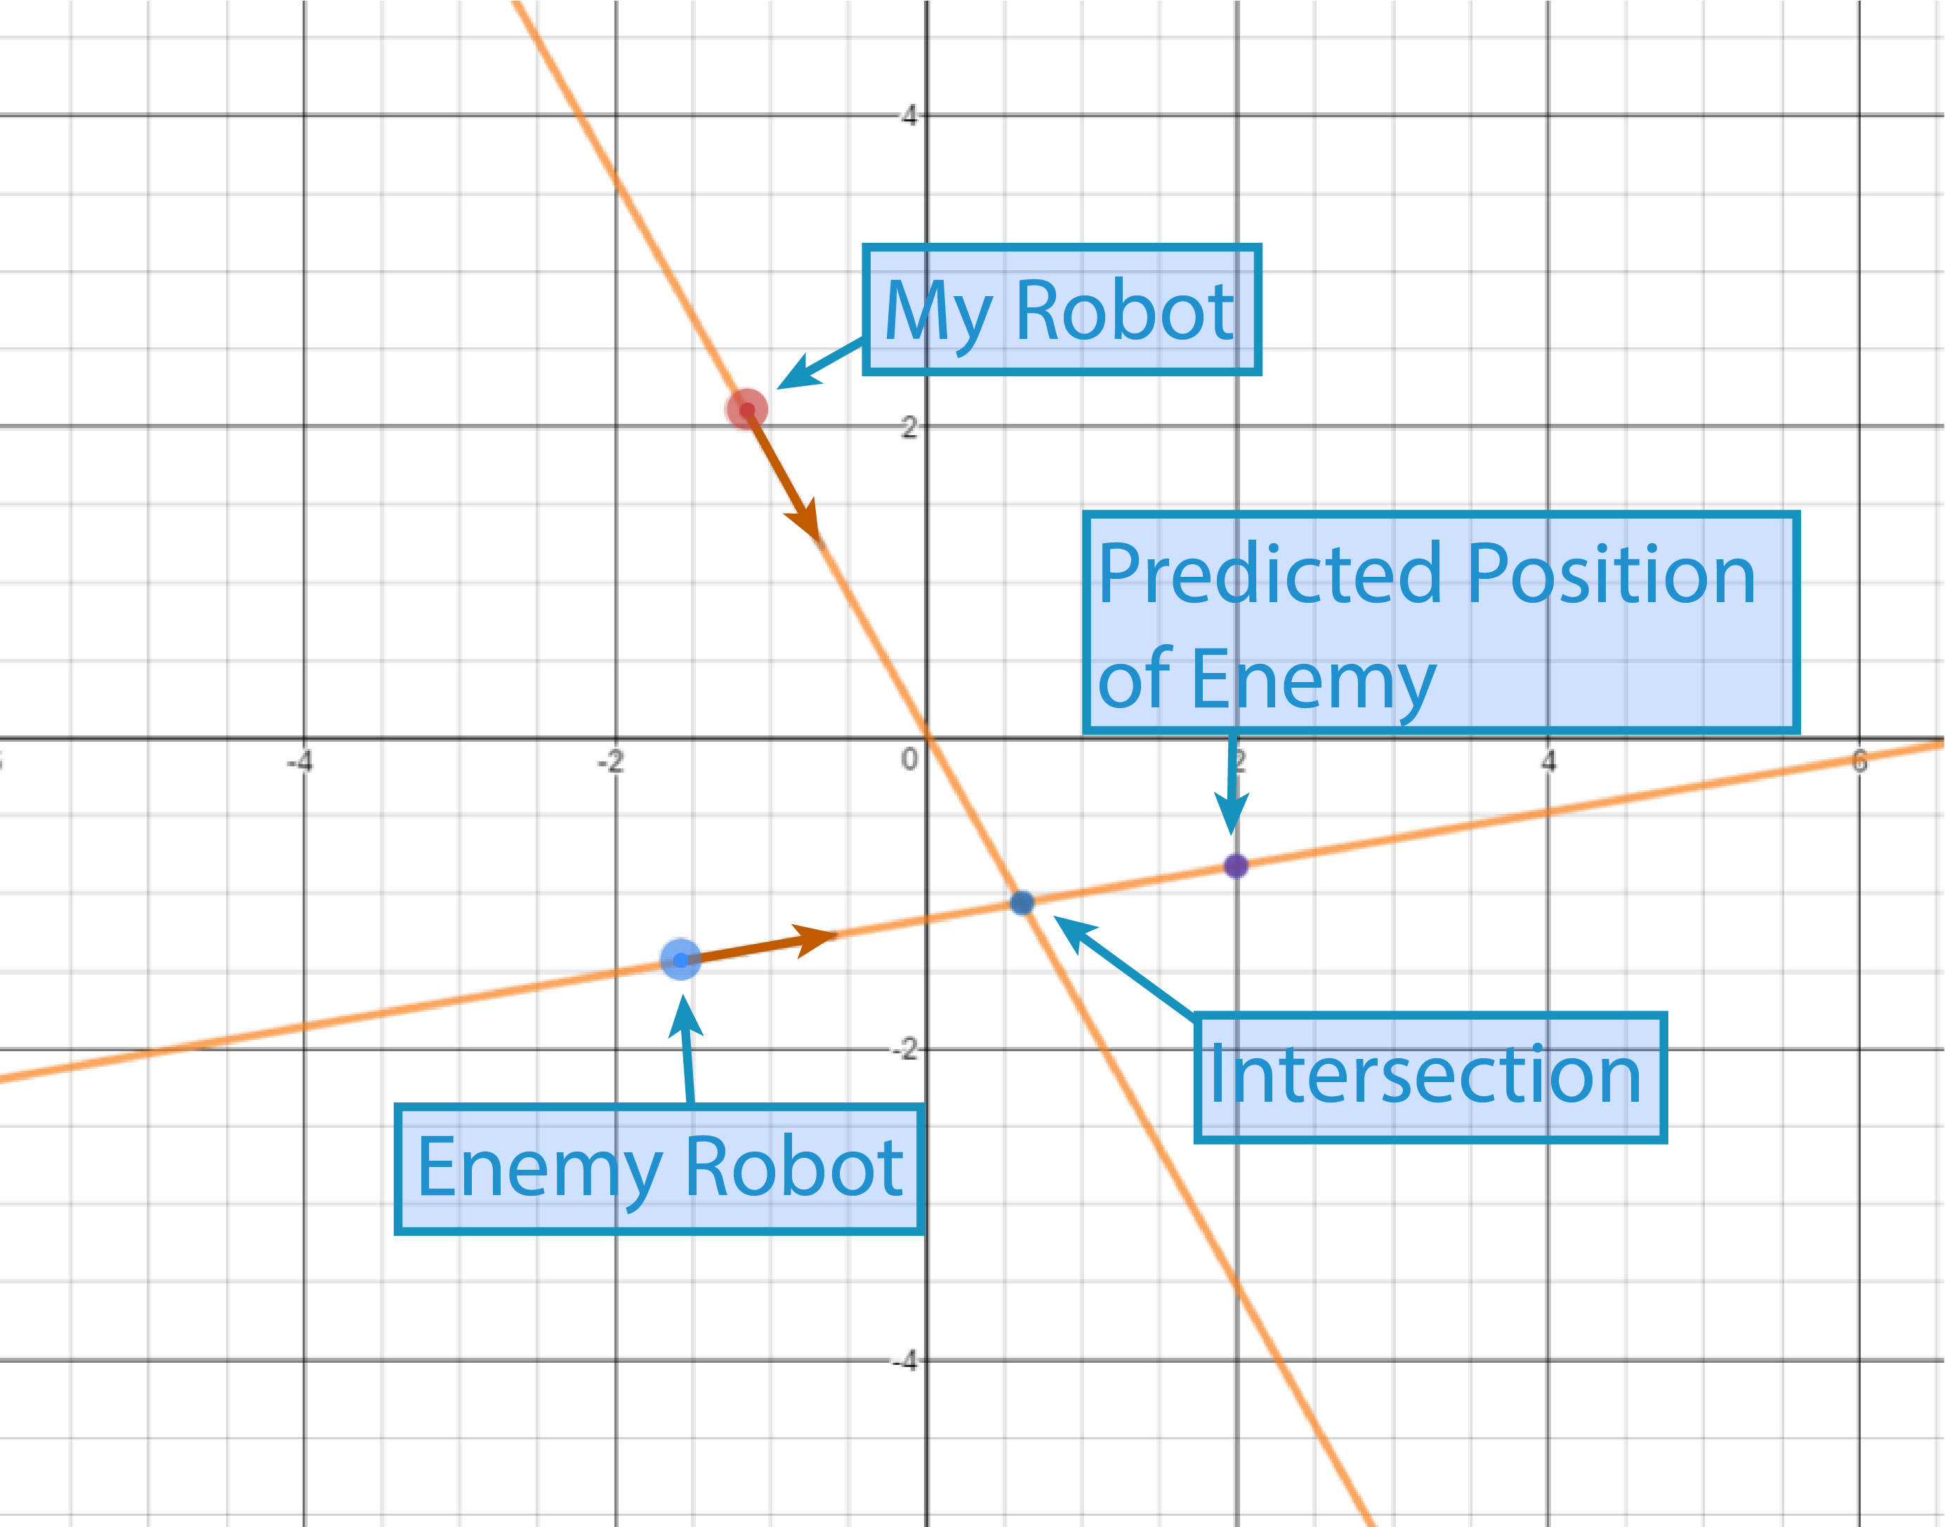

The targeting algorithm aims and fires the turret. The robot will attempt to 'lead the shot' by taking into account the current position, speed, and heading of the target as well as the distance to the target and the speed of bullets. Once the gun is ready to fire and the shot is aimed, the turret will fire. Leading the shot is very important because due to the speed of bullets, any considerable distance will cause shots to lag behind significantly.

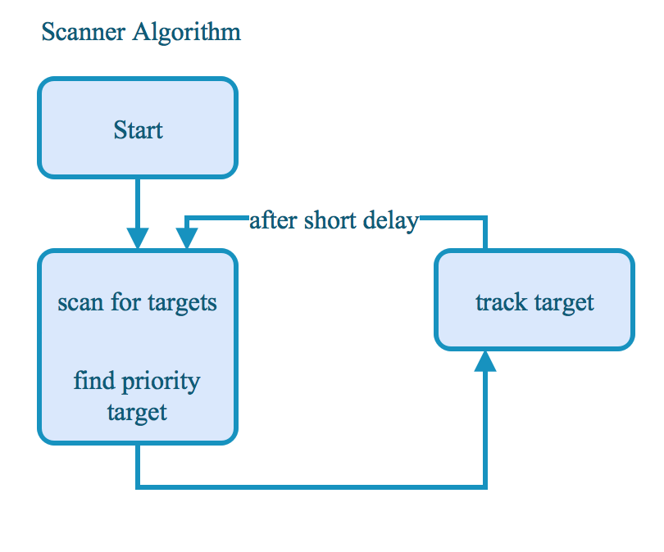

The driving algorithm is primarily state based. The main states are avoid wall, approach enemy, avoid enemy, avoid enemy fire, and idle. Idle is the default state. In this state, the robot travels forward with a slight arc. The Avoid wall state is the highest priority state. In this state, the robot will attempt to avoid hitting the wall. Hitting the wall would cause the robot to stop and render it a "sitting duck". Approach enemy occurs when the robot is too far away to land a shot with any hope of accuracy. Therefor the robot attempts to approach its target so that it can make a better shot. If the robot is too close to an enemy, the robot will attempt to turn away and regain a safe distance from the enemy. This algorithm doesn't 'avoid at all costs'. This means that there is a possibility of ramming the enemy, if this occurs, the robot will continue to move forward (while still attempting to turn away). This damages the other robot and is more beneficial than just running away. Avoid enemy fire is slightly different. This state is not a "lasting state". This means that when the robot gets hit by a bullet, it will enter this state and preform an evasive action but once the action is preformed, the state is exited. While in this state, the evasive action is to orient perpendicular to the direction that the shots are coming from. This causes the robot to travel perpendicular to the bullets (and therefor travel out of the line of fire) when the next state is entered.

